.
Ala Hotel California
Technisch design

Name: Hasan Coskun
SN: 1045645
Class: VO8E-AMO1

Index
1 Resume 2
1.1 Summary for the customer 2
1.2 Version management 2
1.3 mailing list 2

2 Ontwikkelomgeving 3
2.1 De technische infrastructuur 3
2.2 programming language / development tool 3

3 Specification from the interface 4
3.1 Interface 4

4 Specification of the database 6
4.1 Specifications of the database 6
4.2 The size of the database 6

5 maintenance and maintenance 7
5.1 Security 7
5.2 Management 7

6 Final conclusion 8
6.1 Accountability 8
6.2 Source documentation 8

1 Resume

1.1 Summary for the customer
This document includes the report on the Technical Design phase of ala hotel california. All
main components as well as conclusions and recommendations are incorporated in this total overview,
with any references to separate extended documents, which are during this phase
are drawn up.

1.2 Version management
Version | Status | Datum | Auteur | Opmerkingen
0.1 | 1.0 | 31-5-2019 | H.Coskun | x

1.3 mailing list
This document is made available to:

Name | E-Mail | Phone Number | Function
Patrick van de Vries | Pvdv12@gmail.com | 06-12324567 | Project Owner
Tarik khadfy | tkhadfy@mborijnland.nl | 06-20373548 | Project Owner
Anton Prajo | aprajo@mborijnland.nl | 06-14839362 | Project Owner
Henry Robben | hrobben@mborijnland.nl | 06-02436787 | Project Owner
Edward Knoop | eknoop@mborijnland.nl | 06-10440211 | Project Owner
Jeffrey Grüne | jgrune@mborijnland.nl | 06-12456555 | Project Owner

2 Ontwikkelomgeving

2.1 De technische infrastructuur

To visit the web application you do not need any required hardware, you also do not have to download anything, it is an online server.

2.2 programming language / development tool

The development tool that I will use is Visual Studio Code or Symfony with this program I will use it to write the code. We use XAMPP to run the application because we have Apache there if I gonna use visual studio code.
With Apache to have the PHP code supported on our application. The programming languages ​​that we want to use is HTML, CSS, PHP, Javascript. We need this to realize our application.

3 Specification from the interface

3.1 Interface

Activity Diagram
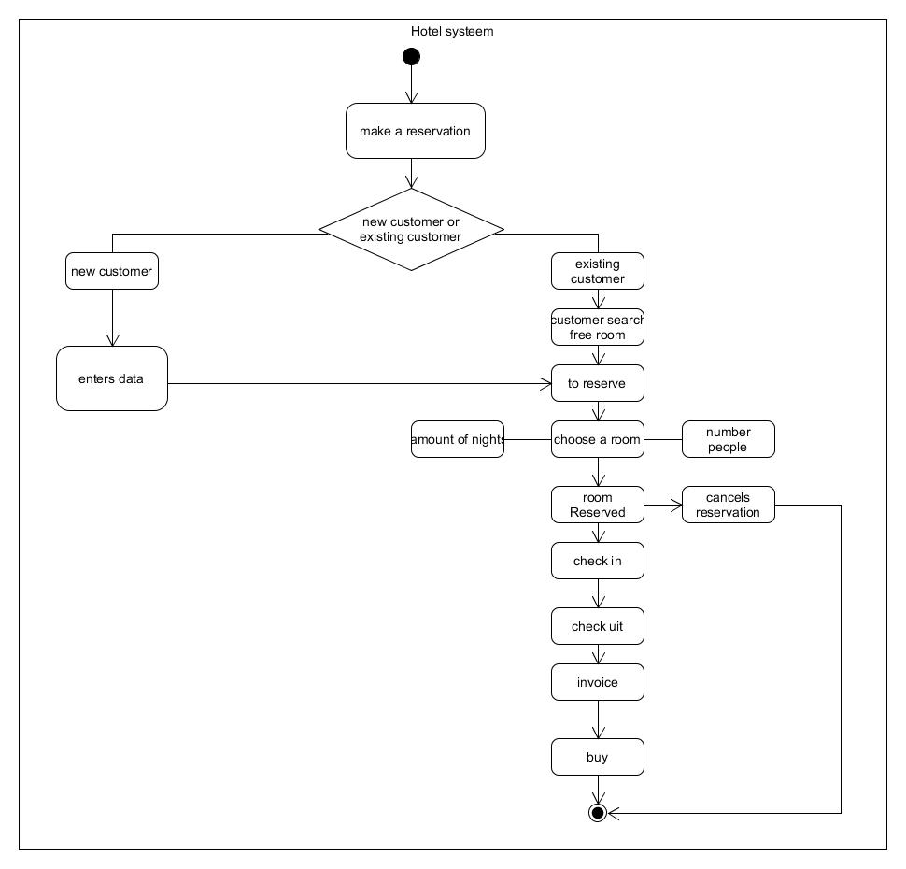

Here you can see when a new customer arrives that has to reserve her.

An existing customer can make a reservation right away, if the customer is going to make a reservation, that room can be chosen, how many nights, number of people.

If the customer has can also be her and her reservation.

Imagine the customer booking his reserve going / checking out when the customer has checked out, the customer gets the invoice and has to pay it.

Wireframe’s

Reservering pagina

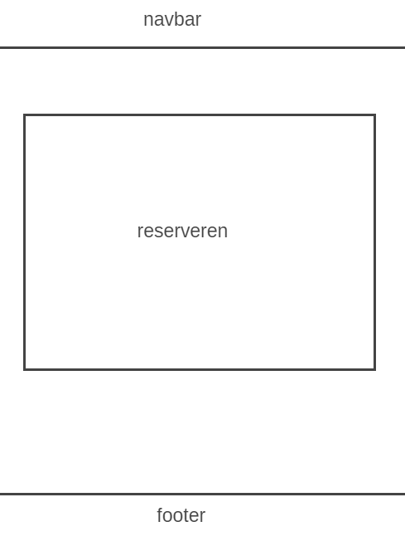

With this page the customer can reserve a room.

At the footer you can see the copyright of the owner of the site.

Over ons pagina

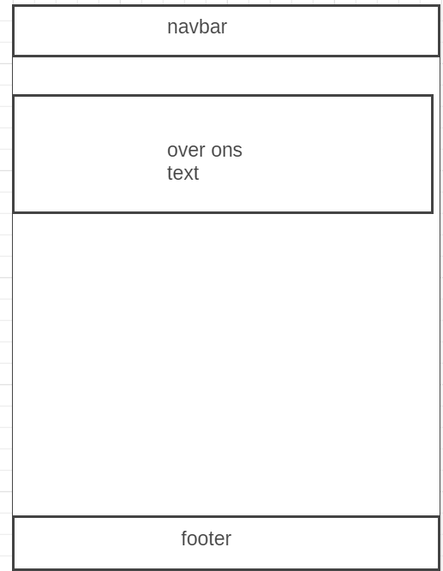

At this page the customer can know information about hotel California.

At the footer you can see the copyright of the owner of the site.

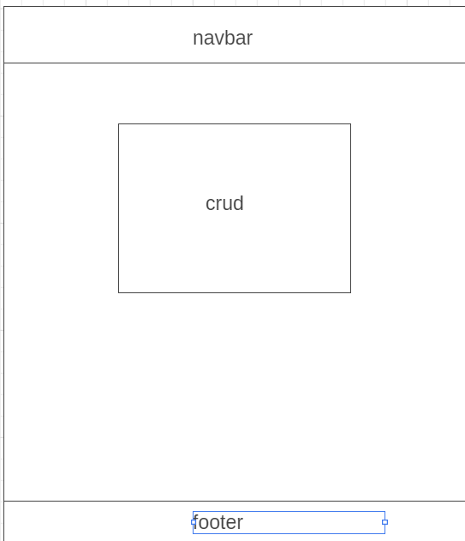

On this page I can change the room, the prices and can see the customer's details.

4 Specification of the database

4.1 Specifications of the database

The fields has an alphanumeric format and formats have also been created for the fields such as city, zip code etc.
The fields that are already empty may not be filled and must remain empty.
There are primary keys at the fields.

Create table ensures that the table is created
varchar is a set of character, integrity maintains norms and values.
primary key is a key in a relational database that is unique to each record.

4.2 The size of the database

The database can be used for a long term with 1 terabyte size.
As soon as a customer places an order, 10 or 11 (depends on name insert) records are created in the database at the customer.

5 maintenance and maintenance

5.1 Security

The application is well protected by a strong password with large letters, small letters and numbers.
We are going to use SSL certificate.

5.2 Management

It must be checked every month at the prices of the hotels and the data of the visitors to the hotel that there will be no more than hundreds of the same user.

6 Final conclusion
The responsibility that I take are the wire frames and the activity diagram.

6.1 Accountability

The problems I encountered were with the database.
I asked for a solution with help.

6.2 Source documentation

I have used the documentation of information requirement and fo.

